ExamGenerator Project
Software Requirements Specification
Version <4.0>

Revision History
Date | Version | Description | Author
<04/13/07> | <1.0> | SRS 1.0 | Group-1
<04/15/07> | <2.0> | SRS 2.0 | Group-1
<04/15/07> | <3.0> | SRS 3.0 | Group-1
<04/16/07> | <4.0> | SRS 4.0 | Group-1

Table of Contents
1. Introduction 5
1.1 Purpose 5
1.2 Scope 5
1.3 Definitions, Acronyms, and Abbreviations 5
1.4 References 5
1.5 Overview 6
2. Overall Description 6
3. Specific Requirements 6
3.1 Functionality 6
3.1.1 Exam generation 7
3.1.2 Login 7
3.1.3 New universities and schools 7
3.1.4 Provide Customer Support. 7
3.2 Usability 7
3.2.1 Graphical User Interface 8
3.2.2 Accessibility 8
3.3 Reliability & Availability 7
3.3.1 Back-end Internal Computers 8
3.3.2 Internet Service Provider 8
3.4 Performance 7
3.4.1 The product shall run from client side. 8
3.4.2 8
3.4.3 The product shall take initial load time depending on internet connection strength which also depends on the media from which the product is run. 8
3.5 Security 7
3.5.1 Data Transfer 8
3.5.2 Data Storage 8
3.6 Supportability 7
3.6.1 Configuration Management Tool 8
3.7 Design Constraints 7
3.7.1 Standard Development Tools 8
3.7.2 Web Based Product 8
3.8 On-line User Documentation and Help System Requirements 7
3.9 Purchased Components 7
3.10 Interfaces 7
3.10.1 There are many types of interfaces as such supported by the E-Store software system namely; User Interface, Software Interface and Hardware Interface. 8
3.10.2 The protocol used shall be HTTPS. 8
3.10.3 The Port number used will be 80. 8
3.10.4 There shall be logical address of the system in IPv4 and IPv6 format. 8
3.10.5 User Interfaces 8
3.10.6 Hardware Interfaces 8
3.10.7 Software Interfaces 8
3.10.8 Communications Interfaces 8
3.11 Licensing Requirements 7
3.12 Legal, Copyright, and Other Notices 7
3.13 Applicable Standards 7
4. Supporting Information 7

Software Requirements Specification

Introduction

The introduction of the Software Requirements Specification (SRS) provides an overview of the entire SRS with purpose, scope, definitions, acronyms, abbreviations, references and overview of the SRS. The aim of this document is to gather and analyze and give an in-depth insight of the complete ExamGenerator by defining the problem statement in detail. Nevertheless, it also concentrates on the capabilities required by stakeholders and their needs while defining high-level product features. The detailed requirements of the ExamGenerator are provided in this document.

Purpose
The purpose of this document is to present a detailed description of the exam generator system. It will explain how it works and the features it possesses, the interfaces of the system, what the system will do, the constraints under which it must operate and how the system will react to external stimuli. This document is intended for both the stakeholders and the developers.

Scope

It focuses on easing the creation of exam and saving significant amount of time from the instructors and teachers in universities and schools during the pandemic.
This SRS is also aimed at specifying requirements of software to be developed.

Definitions, Acronyms, and Abbreviations

Portal | Official website of a university or school on which announcements are made or necessary files are uploaded.
FAQ | Frequently Asked Questions

References
The references are:

- ExamGenerator Structural Model
- ExamGenerator Behavioral Model

Overview

The remaining sections of this document provide a general description, including characteristics of the users of this project, the product's hardware, and the functional and data requirements of the product. General description of the project is discussed in section 2 of this document. Section 3 gives the functional requirements, data requirements and constraints and assumptions made while designing the ExamGenerator. It also gives the user viewpoint of product. Section 3 also gives the specific requirements of the product. Section 3 also discusses the external interface requirements and gives detailed description of functional requirements. Section 4 is for supporting information.

Overall Description

This document contains the problem statement that the current system is facing which is hampering the growth opportunities of the company. It further contains a list of the stakeholders and users of the proposed solution. It also illustrates the needs and wants of the stakeholders that were identified in the brainstorming exercise as part of the requirements workshop. It further lists and briefly describes the major features and a brief description of each of the proposed system.

The following SRS contains the detail product perspective from different stakeholders. It provides the detail product functions of ExamGenerator with user characteristics permitted constraints, assumptions and dependencies and requirements subsets.

Specific Requirements

The specific requirements are –

Functional Requirements

Introduction –

This subsection contains the requirements for the ExamGenerator. These requirements are organized by the features discussed in the vision document. Features from vision documents are then refined into use case diagrams and to sequence diagram to best capture the functional requirements of the system. All these functional requirements can be traced using tractability matrix.

Exam generation

The instructor shall be able to personalize the exam.

The instructor shall be able to set the title

The instructor shall be able to set the exam duration

The instructor shall be able to set the type of exam (e.g., true/false, multiple choice and short answer)

The instructor shall be able to set the open and close time of exam.

The instructor shall be able to see and set the advanced settings

Shall the examiners return to previous questions

Shall the examiners see the result directly after finishing the exam

The instructor shall be able to write question statement and the choices.

The instructor shall be able to set the correct answer.

The instructor shall be able to save a `.exa` file which is recognizable by the portal.

Login

The instructor shall be able to login by giving her username and password

The system shall authorize the user

The system shall send a NACK or ACK message to user

The system shall provide a ‘forget password’ service

New universities and schools

System shall be able to add new universities or schools

System shall be able to allow all instructors sign in using their workplace portal username and password

Provide Customer Support.

The system shall provide online help, FAQ’s customer support, and sitemap options for customer support.

The system shall allow user to select the support type he wants.

The system shall allow user to enter the customer and product information for the support.

The system shall display the customer support contact numbers on the screen.

The system shall display the online help upon request.

The system shall display the FAQ’s upon request.

Use Cases

Instructor Use Case
Diagram:
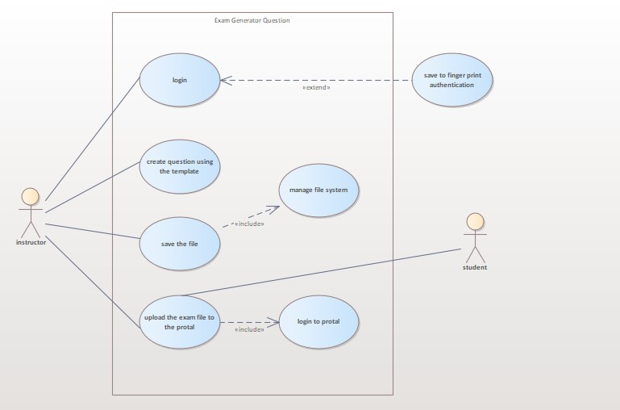
Brief Description:
The instructor shall generate a exam and get an output .exa file.
Initial Step-By-Step Description:
- an instructor should login using his/her portal's username and password
- instructor chooses the subject for which he wants to generate exam
- chooses a title for exam
- chooses a time limit
- fill the advanced settings (e.g. moving back is allowed)
- instructor chooses the type of exam (e.g. yes/no, short answer, multiple choice, long answer)
- writes the question statement or upload an image for each question
- indicates the correct answer (yes/no, short answer or multiple choice)
- repeat 4 and 5 until it is finished
- press save button
- the exam is saved as a `.exa` file which is recognizable by university's portal

Dean Use Case
Diagram:
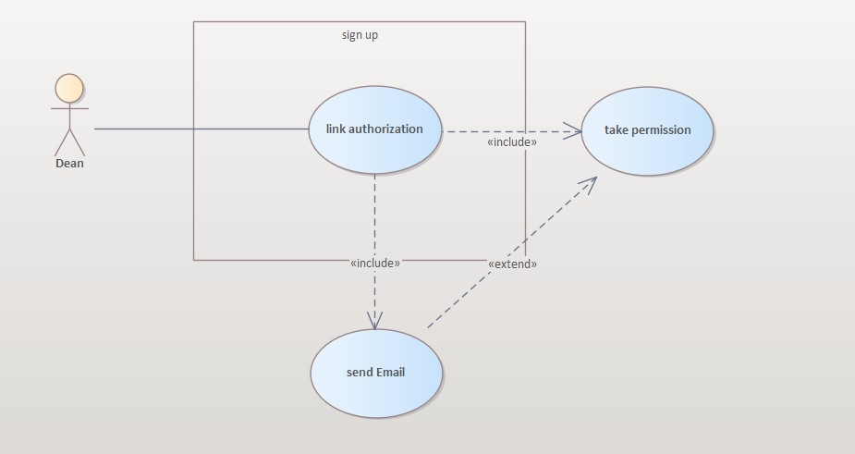
Brief Description:
Dean of the university shall be able to sign up by sending a request to the system.
Initial Step-by-Step description:
- Ask permission from instructors by sending an email to them
- Send an email with authorization of consenting instructors to the managers

Nonfunctional Requirements

Graphical User Interface

The system shall provide a uniform look and feel between all the activities.

The system shall provide a digital image for each product in the product catalog.

The system shall provide use of icons and toolbars.

Accessibility

The system shall provide handicap access.

Reliability & Availability

Back-end Internal Computers

The system shall provide storage of all databases on redundant computers with automatic switchover.

The system shall provide for replication of databases to off-site storage locations.

Internet Service Provider

Performance

The product shall run from client side.

The product shall take initial load time depending on internet connection strength which also depends on the media from which the product is run.

Security

Data Transfer

The system shall use secure sockets in all transactions that include any confidential customer information.

The system shall automatically log out all customers after a period of inactivity.

Data Storage

The customer’s web browser shall never display a customer’s password. It shall always be echoed with special characters representing typed characters.

The system’s back-end servers shall never display a customer’s password. The customer’s password may be reset but never shown.

The system’s back-end servers shall only be accessible to authenticated administrators.

The system’s back-end databases shall be encrypted.

Supportability

Configuration Management Tool

The source code developed for this system shall be maintained in configuration management tool.

Design Constraints

Standard Development Tools

The system shall be built using a standard web page development tool that conforms to either IBM’s CUA standards or Microsoft’s GUI standards.

Web Based Product

There are no memory requirements

The product must be stored in such a way that allows the client easy access to it.

Response time for loading the product should take no longer than one minute.

A general knowledge of basic computer skills is required to use the product

On-line User Documentation and Help System Requirements

Purchased Components

Interfaces

There are many types of interfaces as such supported by the E-Store software system namely; User Interface, Software Interface and Hardware Interface.

The protocol used shall be HTTPS.

The Port number used will be 80.

There shall be logical address of the system in IPv4 and IPv6 format.

User Interfaces
The user interface for the software shall be compatible to any browser such as Internet Explorer, Mozilla or Netscape Navigator by which user can access to the system.
The user interface shall be implemented using any tool or software package like Java Applet, MS Front Page, EJB etc.

Hardware Interfaces

Since the application must run over the internet, all the hardware shall require to connect internet will be hardware interface for the system. As for e.g. Modem, WAN – LAN, Ethernet Cross-Cable.

Software Interfaces

- The e-store system shall communicate with the Configurator to identify all the available components to configure the product.
- The e-store shall communicate with the content manager to get the product specifications, offerings and promotions.
- The e-store system shall communicate with billPay system to identify available payment methods , validate the payments and process payment.
- The e-store system shall communicate to credit management system for handling financing options.
- The e-store system shall communicate with CRM system to provide support.
- The e-store system shall communicate with Sales system for order management.
- The e-store system shall communicate with shipping system for tracking orders and updating of shipping methods.
- The e-store system shall communicate with external Tax system to calculate tax.
- The e-store system shall communicate with export regulation system to validate export regulations.
10. The system shall be verisign like software which shall allow the users to complete secured transaction. This usually shall be the third party software system which is widely used for internet transaction.

Communications Interfaces

The e-store system shall use the HTTP protocol for communication over the internet and for the intranet communication will be through TCP/IP protocol suite.

Licensing Requirements
Not Applicable

Legal, Copyright, and Other Notices

ExamGenerator should display the disclaimers, copyright, word mark, trademark and product warranties of the University Of Amirkabir.

Applicable Standards
It shall be as per the industry standard.

Supporting Information

Please refer the following document:
- Vision document for E-store.s
- Use case analysis.
- Structural models.
- Behavioral models.
- Nonfunctional requirements model.
- Traceability Matrix.
- Project Plan

